For creativity, learning, design and play
ANNUAL REPORT and ACCOUNTS
For the year ending March 2016

Wandsworth Work and Play
Established: 1987. Charity number: 1041641. Company number: 2234306
WaP SCRAPSTORE ANNUAL REPORT and ACCOUNTS 2015/16
CONTENTS
Introduction 3
Our Purposes and Activities 4
Achievements and Performance 6
Key Statistics 9
Chairs Report, Treasurers Report and Financial Review 12
Financial Policies and Risk 16
Structure, Governance and Management 18
Reference and Administrative Details 19
Accounts 21

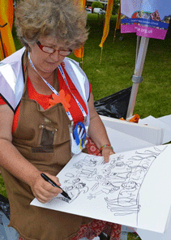
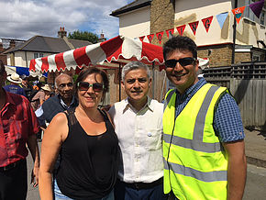

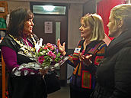
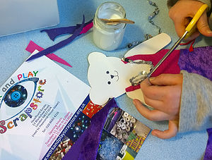
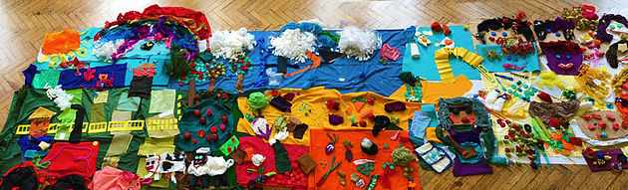

INTRODUCTION
The Trustees present their annual director’s report together with the financial statements of the charity for the year ended 31 March 2016 which are also prepared to meet the requirements for a directors’ report and accounts for Companies Act purposes.
As a charity registered in England and Wales, the charitable company acts and reports in accordance with the Charity Commission for England and Wales’ guidance on public benefit and the Charities Act 2011.
The financial statements comply with the Charities Act 2011, the Companies Act 2006 and Accounting and Reporting by Charities: Statement of Recommended Practice applicable to charities preparing their accounts in accordance with the Financial Reporting Standard for Smaller Entities.

OUR PURPOSES AND ACTIVITIES
Purpose (also known as Charitable Objects)
- To provide or assist in the provision of resources and facilities in the interests of social welfare for recreation or other leisure time occupation of individuals who have need of such facilities by reason of their age, infirmity or disability, financial hardship or social circumstances with the object of improving their conditions of life.

- To advance the education of the public in general on the reuse of scrap and waste materials in order to protect the environment in particular, but not exclusively, by:

- Developing crafting and artistic skills through workshops, tours, tutorials, worksheets and other forms of communication on how waste products, scrap, junk or surplus materials from domestic and commercial organisations can be reused in a creative way.

- Encouraging a greater awareness amongst the general public, by participating in community events, outreach work and other activities, of the opportunity for artistic and creative activity using materials that may otherwise be regarded as waste, thereby offering protection to the environment.

Vision
The promotion of artful re-use through the sharing of reclaimable or ‘lost’ resources for environmental and community benefit.

Mission

To broker the sharing of donated, re-useable surplus/waste materials from a wide range of commercial and domestic contributors with diverse educational and community groups and individuals for artistic, educational, recreational or therapeutic benefit throughout South London.

Activities (that Provide Public Benefit from delivering our Purpose/Vision/Mission)
- We take and process a wide and unique range of donated clean and re-useable surplus/waste materials from businesses and individuals otherwise destined for incineration, landfill or long-term storage. We reduce carbon emissions by diverting waste and slowing down the waste cycle.
- We process and give access to these materials to a significant section of the public, typically schools, charities, community groups, arts organisations, students and families who become our members (including their beneficiaries) for their use in education, arts, craft, design, creative play, therapy activities, who otherwise would not have these access opportunities because of cost and location barriers.
- We give advice, information, training and resources in creative re-use of materials and avoiding environmental damage from waste, to our members and the wider public. This is through a variety of social enrichment means, including events and workshops in our premises and in the community, and through on-line communications.
- We promote and create opportunities for the involvement and skills development of a diverse range of volunteers from all sections of the community.
- We promote dialogue with our stakeholders to improve our performance.

These activities are expressed as operational objectives for the volunteers and staff:
- Provide an inspiring ‘store’ of diverse, re-useable (for education, arts, craft, design, creative play, therapy) materials to a defined member population
- Offer a wide and deep range of economical membership opportunities in order for maximum inclusion
- Divert carbon through encouraging commercial and domestic organizations and individuals to minimize waste/slow down the waste cycle and donate their surplus for re-use
- Provide diverse volunteering opportunities for all sections of the community
- Seek (re-use, artistic, therapeutic) educational and personal and social enrichment opportunities within the community – e.g. workshops, management of/participation in events, teacher training

ACHIEVEMENTS AND PERFORMANCE
We have made significant achievements in a variety of our key performance indicators this year:

Scrapstore Membership

Our membership has increased significantly this year with a total of 373 discrete members compared with 288 last year, an increase in membership income of 47% from £17,211 to £25,315.

Over half of our members are from Wandsworth. The rest are spread widely throughout South London (significant cohorts in Lambeth and Merton) and further afield - as far as Kent.

Our membership dynamic has changed this year to include more home educators, students and individual community artists, tutors and therapists. We have sadly lost a significant proportion of our community groups due to funding cuts. Our membership base remains diverse including schools and nurseries, students, families and a wide range of community groups and artists (many working with disadvantaged groups)

Our end-user number (beneficiaries) has remained relatively constant year-on-year at 24,302 end users. - Despite our increase in overall membership, our end-user number has not changed significantly due to the change in dynamic to smaller membership groups and an increase in accuracy of our recording vs estimated figures last year.

Our number of discrete visits by members to the store to collect materials was 1505, with an average number of 31 visits per week. This compares favourably to 950 visits last year and an average of 24 visits per week.

Members estimated that the value of the items they took came to a total of around £95,000 this year compared to £84,500 last year - which demonstrates that they feel they are getting value from the Scrapstore. This is a subjective figure which is indicative only as each member makes a personal judgement as to what their collection is worth to them (one person’s treasure is another’s junk!). Not all members give a quantitative value on what they take from the Scrapstore. The Charity feels that there is no reliable measure for these to be accounted for in the Statement of Financial Activities as required by SORP (FRSSE).

Following the results of a member survey, since 1st April 2016 we have been open on Tuesday evenings after securing a small grant from Wandsworth Council to support us in some of the additional costs of this activity.

Donated materials

This year, we diverted 23.808 tonnes of waste away from landfill or incineration. Our donors are a mix of commercial and domestic, with a total of 80 different suppliers for 2015-16. We are doubling our intake of supplies year-on-year.

Volunteer Contributions

The number, diversity and productivity of our volunteers has increased year on year. We had 27 regular volunteers this year, including young people undertaking work experience and students between studies; the unemployed; professional people seeking volunteering opportunities and older people. We hosted 1 Corporate Group (Google) - 10 volunteers this year and welcomed 7 'speed' (one-off) volunteers this year.

Our volunteers are critical to our work as they provide the primary manpower to process our mountains of donated waste materials into reusable treasure and display it in the store. They also make a highly valuable contribution in running workshops/demos, facilitating community involvement and providing members with creative ideas. In addition, particular volunteers donate their time to collect supplies and Susanne manages our social media, website and newsletter drafting and distribution. Other volunteers join us from time-to-time and provide specialist professional advice and expertise.

We directly impact the well-being of our volunteers through generating a friendly, safe community-centred environment where all contributions are valued. In addition, we support the future employability of certain volunteers through improving self-confidence and building skills.

Volunteer hours recorded for this year were 3906.55 hours - the equivalent of 387 working days, an average of 78 hours of volunteer time per week. Numerous other hours were worked over weekends and at home (only hours worked on-site at the Scrapstore are monitored).

Community Involvement

We ran or played a significant role in 20 separate creative community events/activities last year, focusing on the joy of communal creativity and raising awareness of the benefits of re-use. We partnered with local community groups and charities, schools, libraries and professional bodies.

We were a significant contributor to Wandsworth Arts Fringe and the Tooting Streets Festival with a variety of craft activities and installations. We facilitated teacher training/education, took our 'junk' wishing tree on a tour (a bar, a library, a school, a church), provided creative opportunities at a ceremony to honour the World War 2 V2 bomb victims in Summerstown, ran an art competition, ran workshops and demos at the Scrapstore, made interactive displays in public places, welcomed the Mayor of Wandsworth to the Scrapstore and opened our doors for an open day.

We 'touched' an estimated 1035 people through these activities.

Media/social media/website/communications

Our website has been much improved with better signposting for our users and notably a wonderful blog page providing regular reports of WaP's activities, news, ideas and affiliations. Our website was visited 13,145 times by 9140 separate users (68% of those were new visitors). 27,957 pages were viewed, showing that each visitor looked at an average of just over 2 pages per visit. The average ‘session’ time was nearly 2 minutes which demonstrates ‘stickiness’ to our site.

We have established regular newsletters and newsflashes to keep our members, friends and suppliers up-to-date with our latest news

Our current social media reach for spreading our messages is: Twitter: 916 followers, Facebook: 293 Likes and Instagram (new this year): 127 followers.

Our new YouTube film of the Scrapstore has had 817 views.

Our events have been regularly included in Wandsworth Council's Art Bulletins and we have had an article in Brightside.

These achievements could not have been made without the input of Susanne White who was employed for a fixed-term as our Digital Marketing Assistant. She continues to provide volunteer support in this area for which we are very grateful.

Operations

Chris Bielby has continued to develop our Office 365 platform. Particular achievements include: the development of user-friendly, accurate membership and suppliers databases; implementation of shared areas to suit the requirements of our various cohorts - staff, volunteers, Trustees.

We have invested significantly in cleaning which has resulted in a fresher, less dusty and more pleasant environment: important for the health, well-being and morale of all of our staff.

Governance

We have improved our employee and volunteer policies to ensure that all of our staff are safe in their work, receive fair treatment and that we meet legislative requirements.

In line with current legislation, we now have 2 on-site trained first aiders to ensure safety of our workforce and store members and visitors.

KEY STATISTICS

Membership

Total membership = 373
Total end user numbers (approx.) = 24,302

MEMBERSHIP BY BOROUGH | Members
Wandsworth | 205
Lambeth | 45
Southwark | 12
Merton | 30
Kensington & Chelsea | 10
Croydon | 8
Lewisham | 11
Other London | 26
Other | 26
 | Total 373

MEMBERSHIP BY TYPE
 | Members
Community Groups | 50
Primary Schools | 60
Secondary Schools | 8
Nurseries | 29
Childminders | 31
Students | 58
Home Educators | 91
Families | 31
Individuals | 15
TOTALS | 373
No. of Umbrella Groups/Clusters in total | 7

Member Collections made in the Year April 2015 – March 2016
Total number of discrete collections made = 1505
Average number of collectors per week = 31
Total indicative value of supplies taken by individual members = £95,000*
*This is a subjective figure which is indicative only as each member makes a personal judgement as to what their collection is worth to them (one person’s treasure is another’s junk!). Not all members give a quantitative value on what they take from the Scrapstore. The Charity feels that there is no reliable measure for these to be accounted for in the Statement of Financial Activities as required by SORP (FRSSE)

Donated materials received and collected

 | From Business Suppliers |  | From Domestic Suppliers
 | Delivered | Collected | Delivered | Collected | Total No. of Donations | Volume collected (Black bags) | Weight (Kg)
April | 1 | 11 | 8 | 3 | 23 | 127 | 2,032
May | 2 | 6 | 3 | 1 | 12 | 74 | 1,184
June | 3 | 3 | 4 | 1 | 11 | 141 | 2,256
July | 0 | 8 | 4 | 0 | 12 | 88 | 1,408
Aug | 2 | 7 | 2 | 0 | 11 | 157 | 2,512
Sept | 3 | 9 | 4 | 0 | 16 | 70 | 1,120
Oct | 7 | 3 | 7 | 0 | 17 | 84 | 1,344
Nov | 5 | 5 | 3 | 0 | 13 | 89 | 1,424
Dec | 0 | 7 | 5 | 1 | 13 | 111 | 1,776
Jan | 2 | 11 | 10 | 0 | 23 | 167.5 | 2,680
Feb | 4 | 9 | 5 | 0 | 18 | 163 | 2,608
Mar | 7 | 15 | 10 | 0 | 32 | 216.5 | 3,464
Total | 36 | 94 | 65 | 6 | 201 | 1488 | 23,808

Total donations weight for year: 23,808kg
Breakdown: Commercial: 65% Domestic: 35%
During this period, we had 80 different suppliers.

Volunteers
Number of regular volunteers = 27
Number of speed volunteers = 7
Number of corporate groups = 1 (10 volunteers)
Total volunteer hours worked in year = 3,906h 55
Average volunteer hours worked per week* = 78h
*50 wks in Period
CHAIR’S REPORT
We have continued to enjoy a further steady year which has led to further consolidation and growth. This is all round – particularly increasing the number of members, and also volunteers, amount of materials, number of visits and workshop activities. This has created an atmosphere of positivity and confidence, particularly as we are seeing more engagement by members in the enterprise.
The Scrapstore model can be a bit hard to grasp at first ‐ what we offer to whom and what we stand for. We are primarily here to give unique value to our members ‐ groups, organisations or individuals who can use materials to create something worthwhile with their users. Sometimes members don’t know what exactly they will do or how, others have a clear vision. Inspiration comes in many ways and Scrapstore volunteers are there to help. Often the process of creation is as important as the outcome.
We have continued to focus on what our members need and responding to their feedback, we have extended our opening hours by opening later into the evening one day a week. This has been well received by members.
We are offering more participation in workshops in the store and by working with multiple partners at outside events. In May 2015, we became significant partners of Wandsworth Arts Fringe and we want this to be an ongoing relationship.
Our success has depended on both strong team spirit working across volunteers, staff and trustees and strong leadership from Sascha Taylor, a consultant running the general manager project, and other key individuals. Chris Bielby, our Office Manager has made a critical contribution with supplies procurement and developing Office 365 and Catherine May does so much for WAPS as volunteer coordinator, doing key roles in the store and as trustee.
We have reviewed our charitable objects or core purpose with advice from the Charity Commission. We have not made any fundamental changes but they are now expressed more accurately and inclusively to ensure public benefit. These are set out in this report, subject to approval at the AGM. Then they will be registered with the Charity Commission. It still remains our intention to simplify our constitution by becoming a Charitable Incorporated Organisation, when legislation permits such a change without unreasonable complexity in the application process. It was not possible last year.
We cannot be complacent about the future. Maintaining the higher standards we have achieved requires constant day to day effort and our operating costs have risen significantly, primarily because we can no longer rely on securing all the management skills we need from volunteers for free. We need to move beyond general management as a project. We have to watch the membership levels carefully as although we have successfully attracted new members, more of our existing members than we would like do not to renew consecutively. It is not always easy to find out why but sometimes they return at a later date when they realise what they are missing!
We have capacity to grow membership overall some more, but we can see that there is a limit in the current premises and with our current infrastructure. We cannot cover our essential costs in the medium term (which we always try to minimise) without either increasing the membership fees, or securing alternative sources of income. Charitable grants continue to be crucial to our viability. We need more, both in diversity and amounts of money, when competition for grants is fiercer than ever. Our good relationship with Wandsworth Council remains critical.
We have retained some experienced trustees, seen some go and others come. The cohesion of the trustee team has been maintained however.
I want to record my deep gratitude to all our dedicated volunteers and trustees who devote so much time and skill to make WAPs successful. My thanks equally go to our small staff team, who give so much more than their job descriptions and give such dedication.
My special thanks go to Susanne, for pulling together this report.

Lucy Hadfield
Chair
TREASURER’S REPORT AND FINANCIAL REVIEW
Financial Review
2015/16 has been another significant year for the Work and Play, as the charity continued through the execution of our long-term restructuring programme, continuing the 2014/15 momentum.
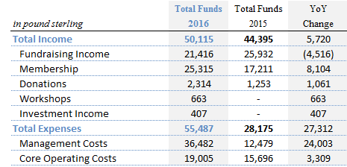
Work and Play principal funding sources were membership fees & donations, financial grants and most recently, additional income stream generated through paid participation in community events and corporate volunteering partnerships.
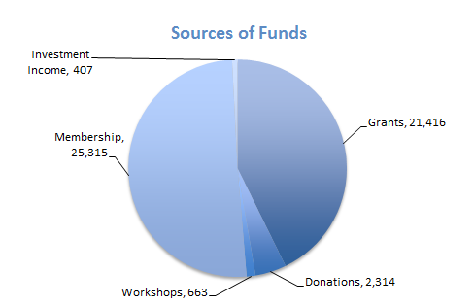
Work and Play total income has improved by 13% to £50,115, mostly on the back of core membership growth.
Membership income has improved significantly (up 47%) to £25,315, with total members at 373. The full operational capacity that Work and Play can support at the moment is 400. This was above the target of £20,000 set for the year. Involvement with the Wandsworth Fringe Festival and targeted marketing campaign were the key contributing factors.
Donations were up 85% at £2,314, while participating in events/workshops and investment income generated additional £663 and £407 in fees respectively.
Work and Play was able to secure £21,416 of grants from the existing donors (Wandsworth Council, Octavia Trust, Leathersellers and Big Society Lottery Fund), down 17% from the previous year. We are very grateful for the generosity of our supporters and sponsors, and rely on the grants to fund a portion of our core fixed costs base, primarily staff salaries.
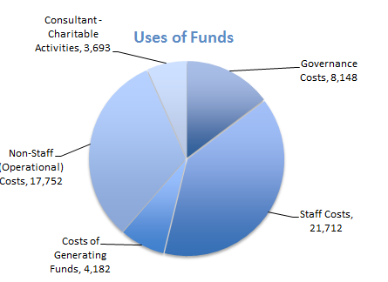
Work & Play uses of funds were mainly management costs and core operating expenses. The increase in costs was driven mainly by salary expenses of a core staff: an office manager and a marketing assistant hired to help with the marketing campaign and to improve the web site and charity’s interaction with the social media. In addition, an experienced consultant was brought in on a contract basis to help to execute the business development plan and prepare the charity for the permanent senior hire in future. Other operational costs were also up by 21%, mainly driven by stock collection fees to support the growing membership base.
I would like to acknowledge Julia Hebblethwaite for her tremendous help in running Work & Play bookkeeping operations for the last 2.5 years.
I would also like to thank everyone for their hard work and for doing such an excellent job in turning the Work and Play charity around, growing the membership and exploring the new ways of generating the income to support the expansion. The store has never felt more buzzing and cheerful!

Evgenia Sorokina
Treasurer/Company Secretary

FINANCIAL POLICIES AND RISK
The Treasurer reports to the Trustees on a quarterly basis, or more regularly should it be required. A budget is prepared at the beginning of each financial year and agreed by the Trustees.

Investment Policy
The Trustees, having regard to the liquidity requirements of operating the Charity, and to the reserves policy have operated a policy of keeping available funds in an interest bearing bank account and seek to achieve a rate of interest which matches inflation as measured by the retail prices index.

Reserves Policy
- The Charity’s contingency operational reserve fund has remained at £30,000 in 2016, with further £12,000 designated to cover additional staff & management costs until the end of December 2016 (£2,000 increase from December 2015)
- £25,000 of £30,000 operational reserve funds are designated to ensure the continuation of the operational activities, while £5,000 were set aside to cover contingent rental costs
- £30,000 operational reserve funds and a portion (£8,000) of the staff & managements designated funds were moved/invested into the 180-day (£20,000) and 120-day (£18,000) fixed rate savings accounts with Secure Trust at the end of August 2015, generating £407 in income fees by the end of March 2016
- The Trustees will continue to establish sufficient funds to support the continuing activities of the Charity
- It is the Trustees’ intention that any surplus funds are invested in a high interest instant access savings account

Risk Review
Risk review focuses on income, supply chain, costs and Health and Safety in premises:
- Control of expenditure, focus on maintenance and generation of income, and awareness of the underlying weaknesses in funding the charity’s operational costs.
- Goods have no cost due to donations of supplies and stock, whilst volunteers make an important contribution to make goods available to members
- Paid staff costs may be greatly affected by part or full time employment commitments and such commitments must be planned in advance and remain under a continuous review by the Trustees
- The Trustees are aware of the specific health and safety risks of the materials handling for staff, volunteers and members, and whilst present in the store, through monitoring the H&S plan
- Trustees to continue reviewing risks on an ongoing basis, and implement systems to mitigate such risks as required

STRUCTURE, GOVERNANCE AND MANAGEMENT
Wandsworth Work and Play is a Charitable Company limited by guarantee (“Company”, “Charity”). The Constitution was agreed and the Company registered under the Companies Act on 23 March 1988 Number 2234306. It is governed by its Memorandum and Articles of Association as amended to allow for current governance arrangement on 21 November 2004. The Company was registered for charitable status with the Charity Commission on 28 October 1994 Number 1041641. Only members of the Company can be appointed as Directors/Trustees.
Trustees of the Charity are also required to be Directors of the Company. They are elected by the membership at the annual AGM, or may be co-opted to the committee and may then stand for election at the next AGM.
At the AGM, one-third of the members, who have been longest in office shall retire and are eligible for re-election.
All significant decisions and actions are agreed formally by the Trustees and documented.
New Trustees receive important governing documents and background on the Charity from the Chair, as well as details of the requirements and expectations of the Trustees. Guidance is given on specific roles by the incumbent of that position or the Chair.
The Trustees have determined that the current constitution needs some amendments to reflect current and preferred practice. They intend to move to a Charitable Incorporated Organisation (CIO) structure to optimise efficiency of governance.

REFERENCE AND ADMINISTRATIVE DETAILS

Registered Name: Wandsworth Work and Play
Charity Number: 1041641
Company Number: 2234306
Registered Address: Hazlehurst Estate, 13 Blackshaw Road, London, SW17 0DA
Chairperson: Lucy Hadfield
Treasurer: Evgenia Sorokina
Company Secretary: Evgenia Sorokina

The directors of the charitable company (the charity) are its trustees for the purpose of charity law. The trustees and officers serving during the year and since the year end were as follows:
Lucy Hadfield 28 Nov 2015 (Re-Elected)
Evgenia Sorokina 28 Nov 2015 (Re-Elected)
Angharad Palin 28 Nov 2015 (Re-elected), Resigned 8 March 2016
Richard Gaskin 28 Nov 2015 (Re-elected), Resigned 11 April 2016
Mariam Bajulaiye 28 Nov 2015 (Elected), Resigned 9 Sept 2016
Justin Davin-Smith 28 Nov 2015 (Elected), Resigned 12 July 2016
Catherine May 28 Nov 2015 (Elected)
Gillian Upton Appointed 8 June 2016
Fiona Lloyd Appointed 24 June 2016

Trustee’s responsibilities in relation to the financial statements
The charity trustees (who are also the directors of Wandsworth Work and Play for the purposes of company law) are responsible for preparing a trustees annual report and financial statements in accordance with applicable law and United Kingdom Accounting Standards (United Kingdom Generally Accepted Accounting Practice)
Company law requires the charity trustees to prepare financial statements for each year which give a true and fair view of the state of affairs of the charitable company and of the incoming resources and application of resources, including the income and expenditure, of the charitable company for that period. In preparing the financial statements, the trustees are required to:
- Select suitable accounting policies and then apply them consistently;
- Observe the methods and principles in the Charities SORP;
- Make judgments and estimates that are reasonable and prudent;
- State whether applicable UK accounting standards have been followed, subject to any material departures disclosed and explained in the financial statements;
- Prepare the financial statements on the going concern basis unless it is not appropriate to presume that the Charity will continue in business.

The Trustees are responsible for maintaining proper accounting records that disclose with reasonable accuracy at any time the financial position of the Charity and to enable them to ensure that the financial statements comply with the Companies Act 2006.
The Trustees are also responsible for safeguarding the assets of the Charity and hence for taking reasonable steps for the prevention and detection of fraud and other irregularities.
The trustees are responsible for the maintenance and integrity of the corporate and financial information included on the charitable company’s website. Legislation in the United Kingdom governing the preparation and dissemination of financial statements may differ from legislation in other jurisdictions.

Approved by Lucy Hadfield, Chair /Date/

Approved by Evgenia Sorokina, Treasurer/Company Secretary /Date/

ACCOUNTS
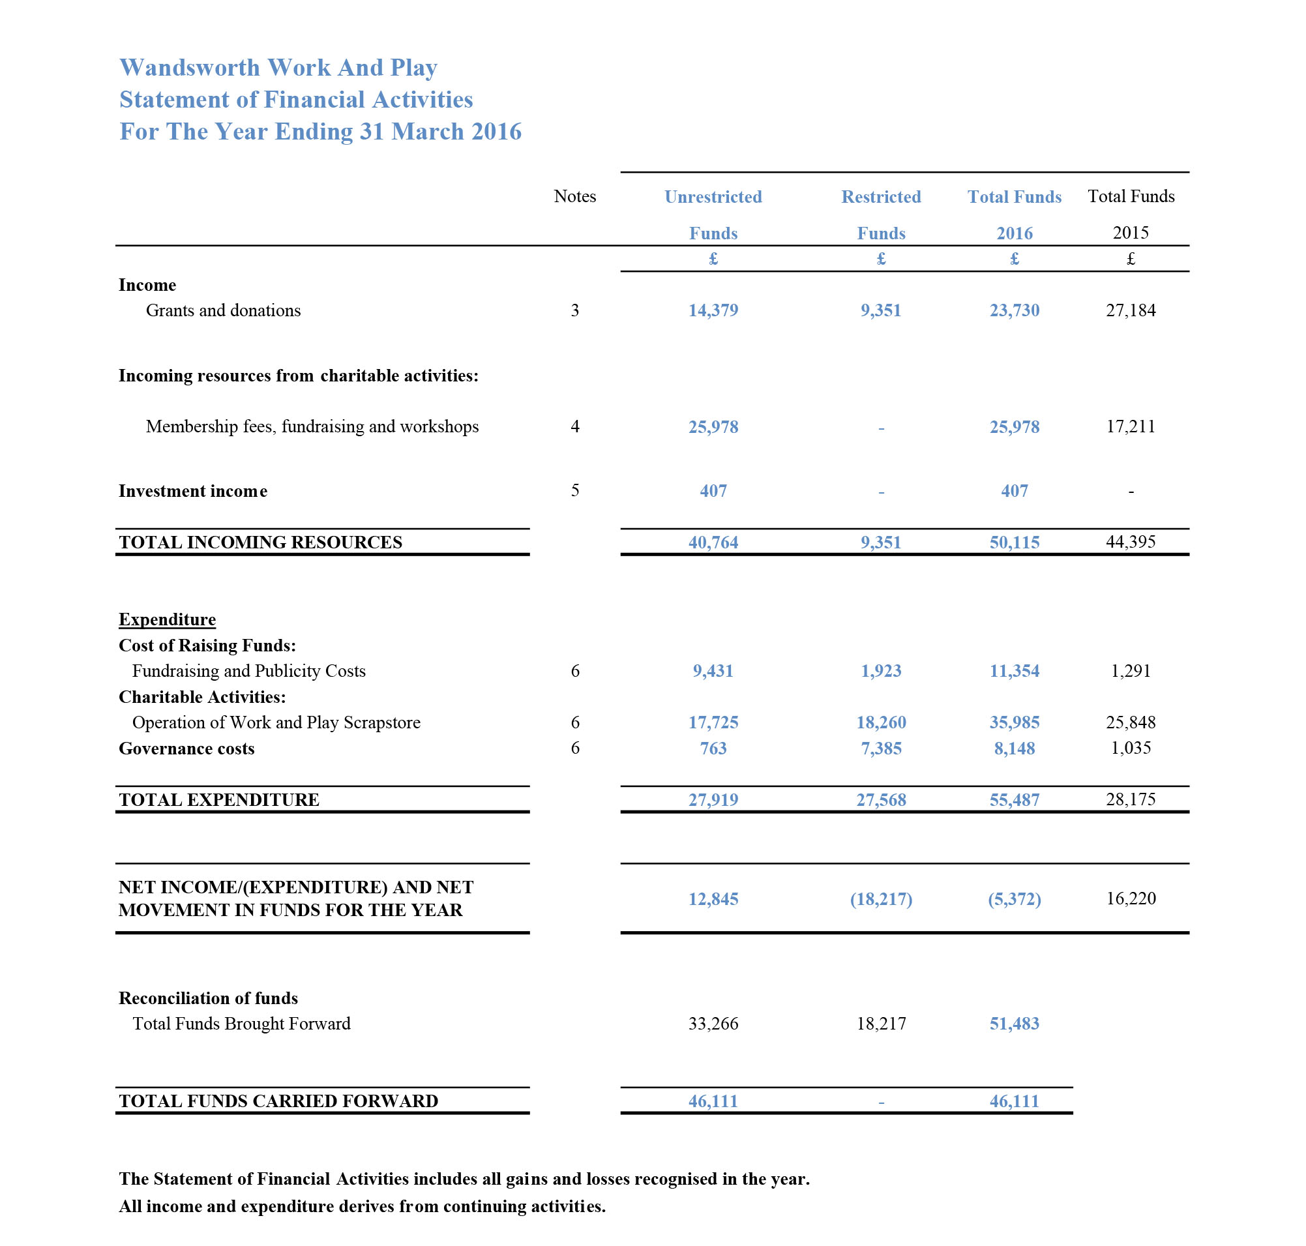

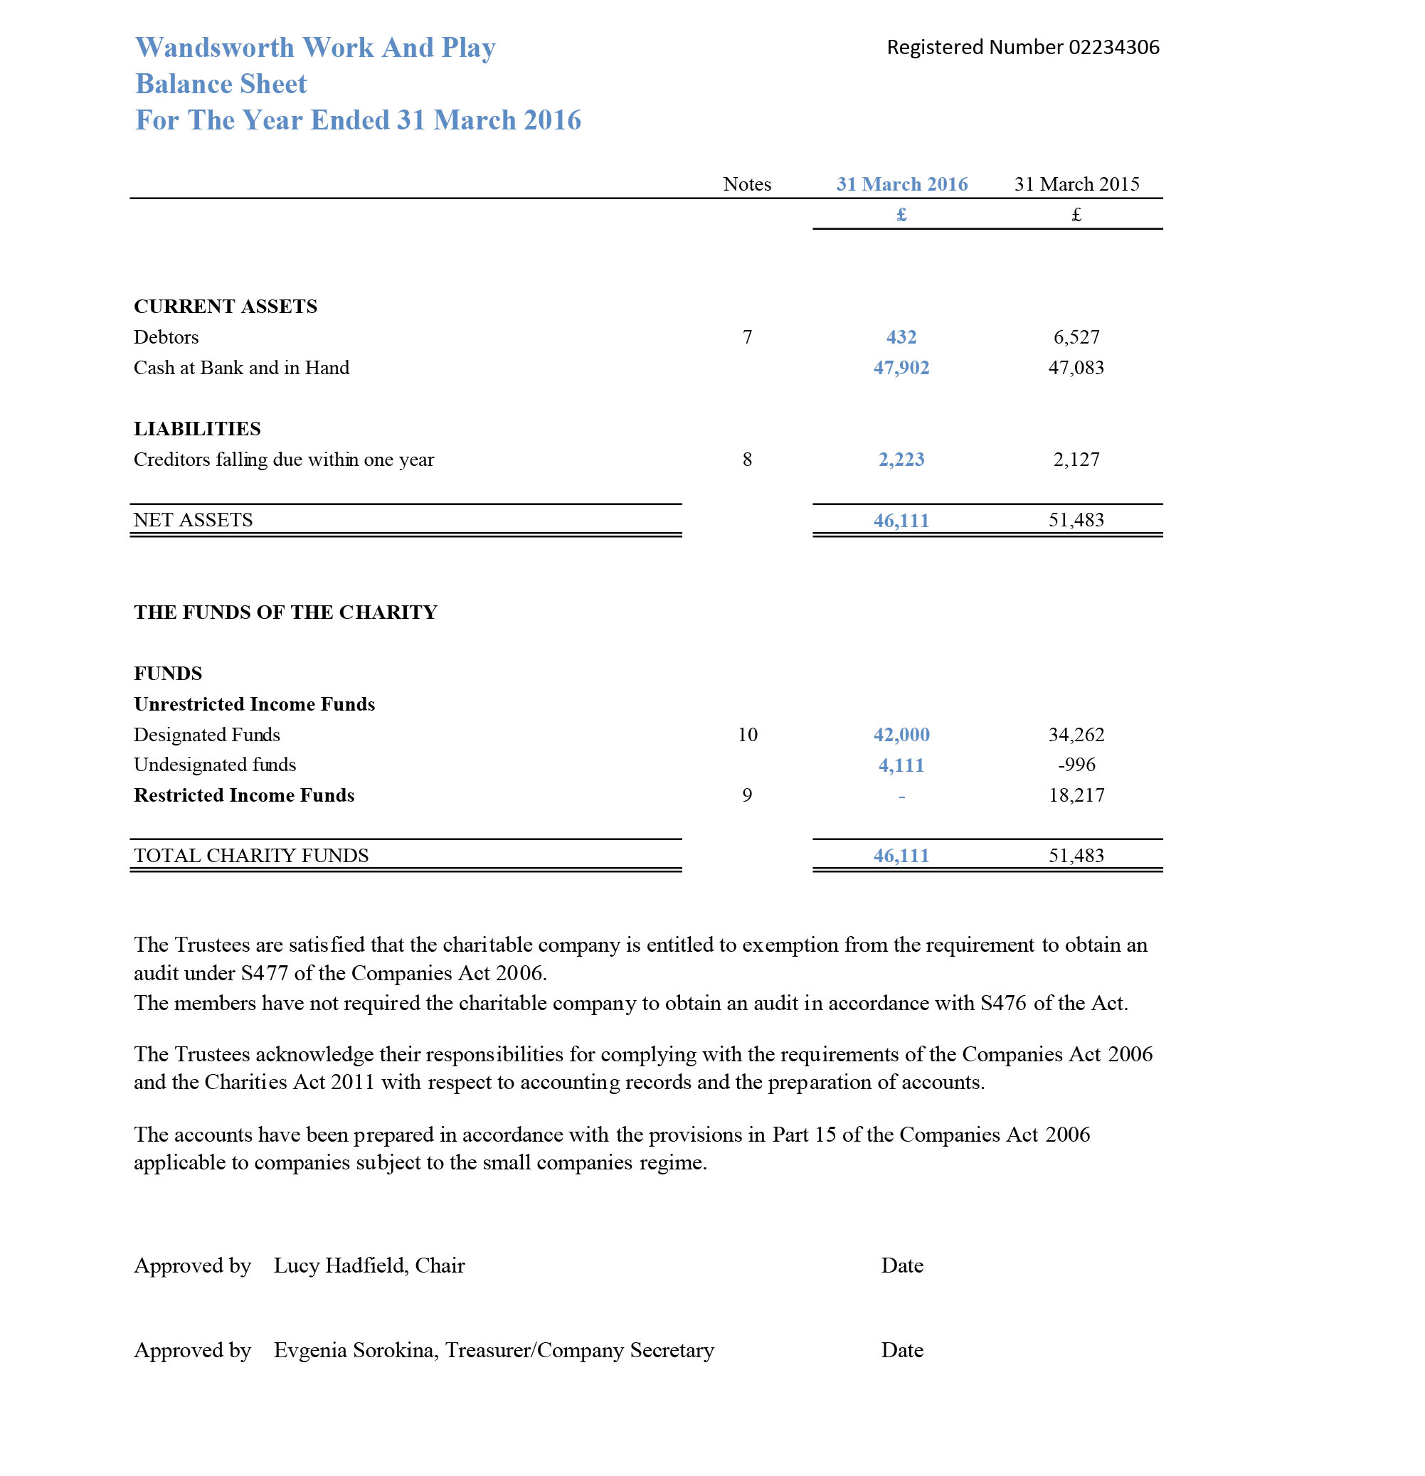

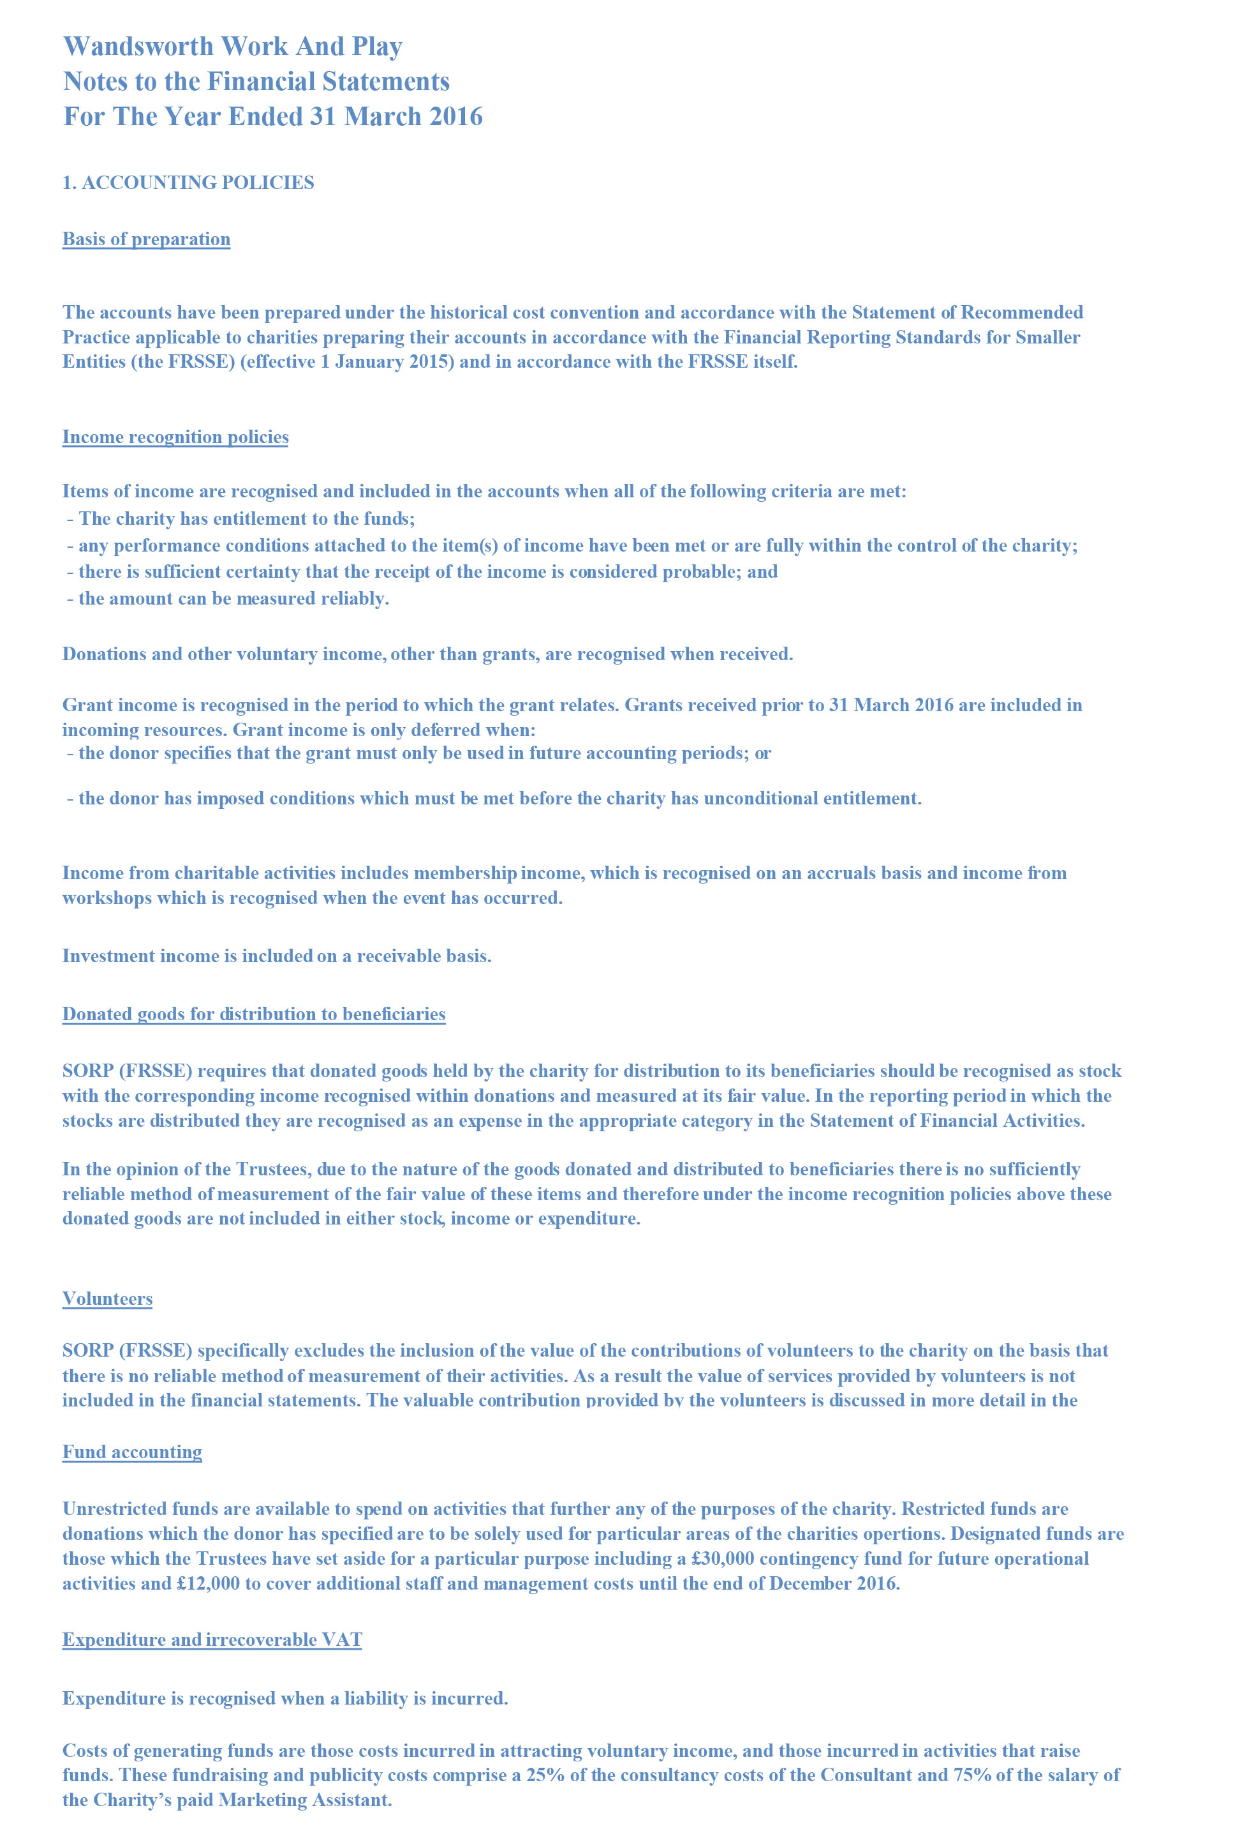
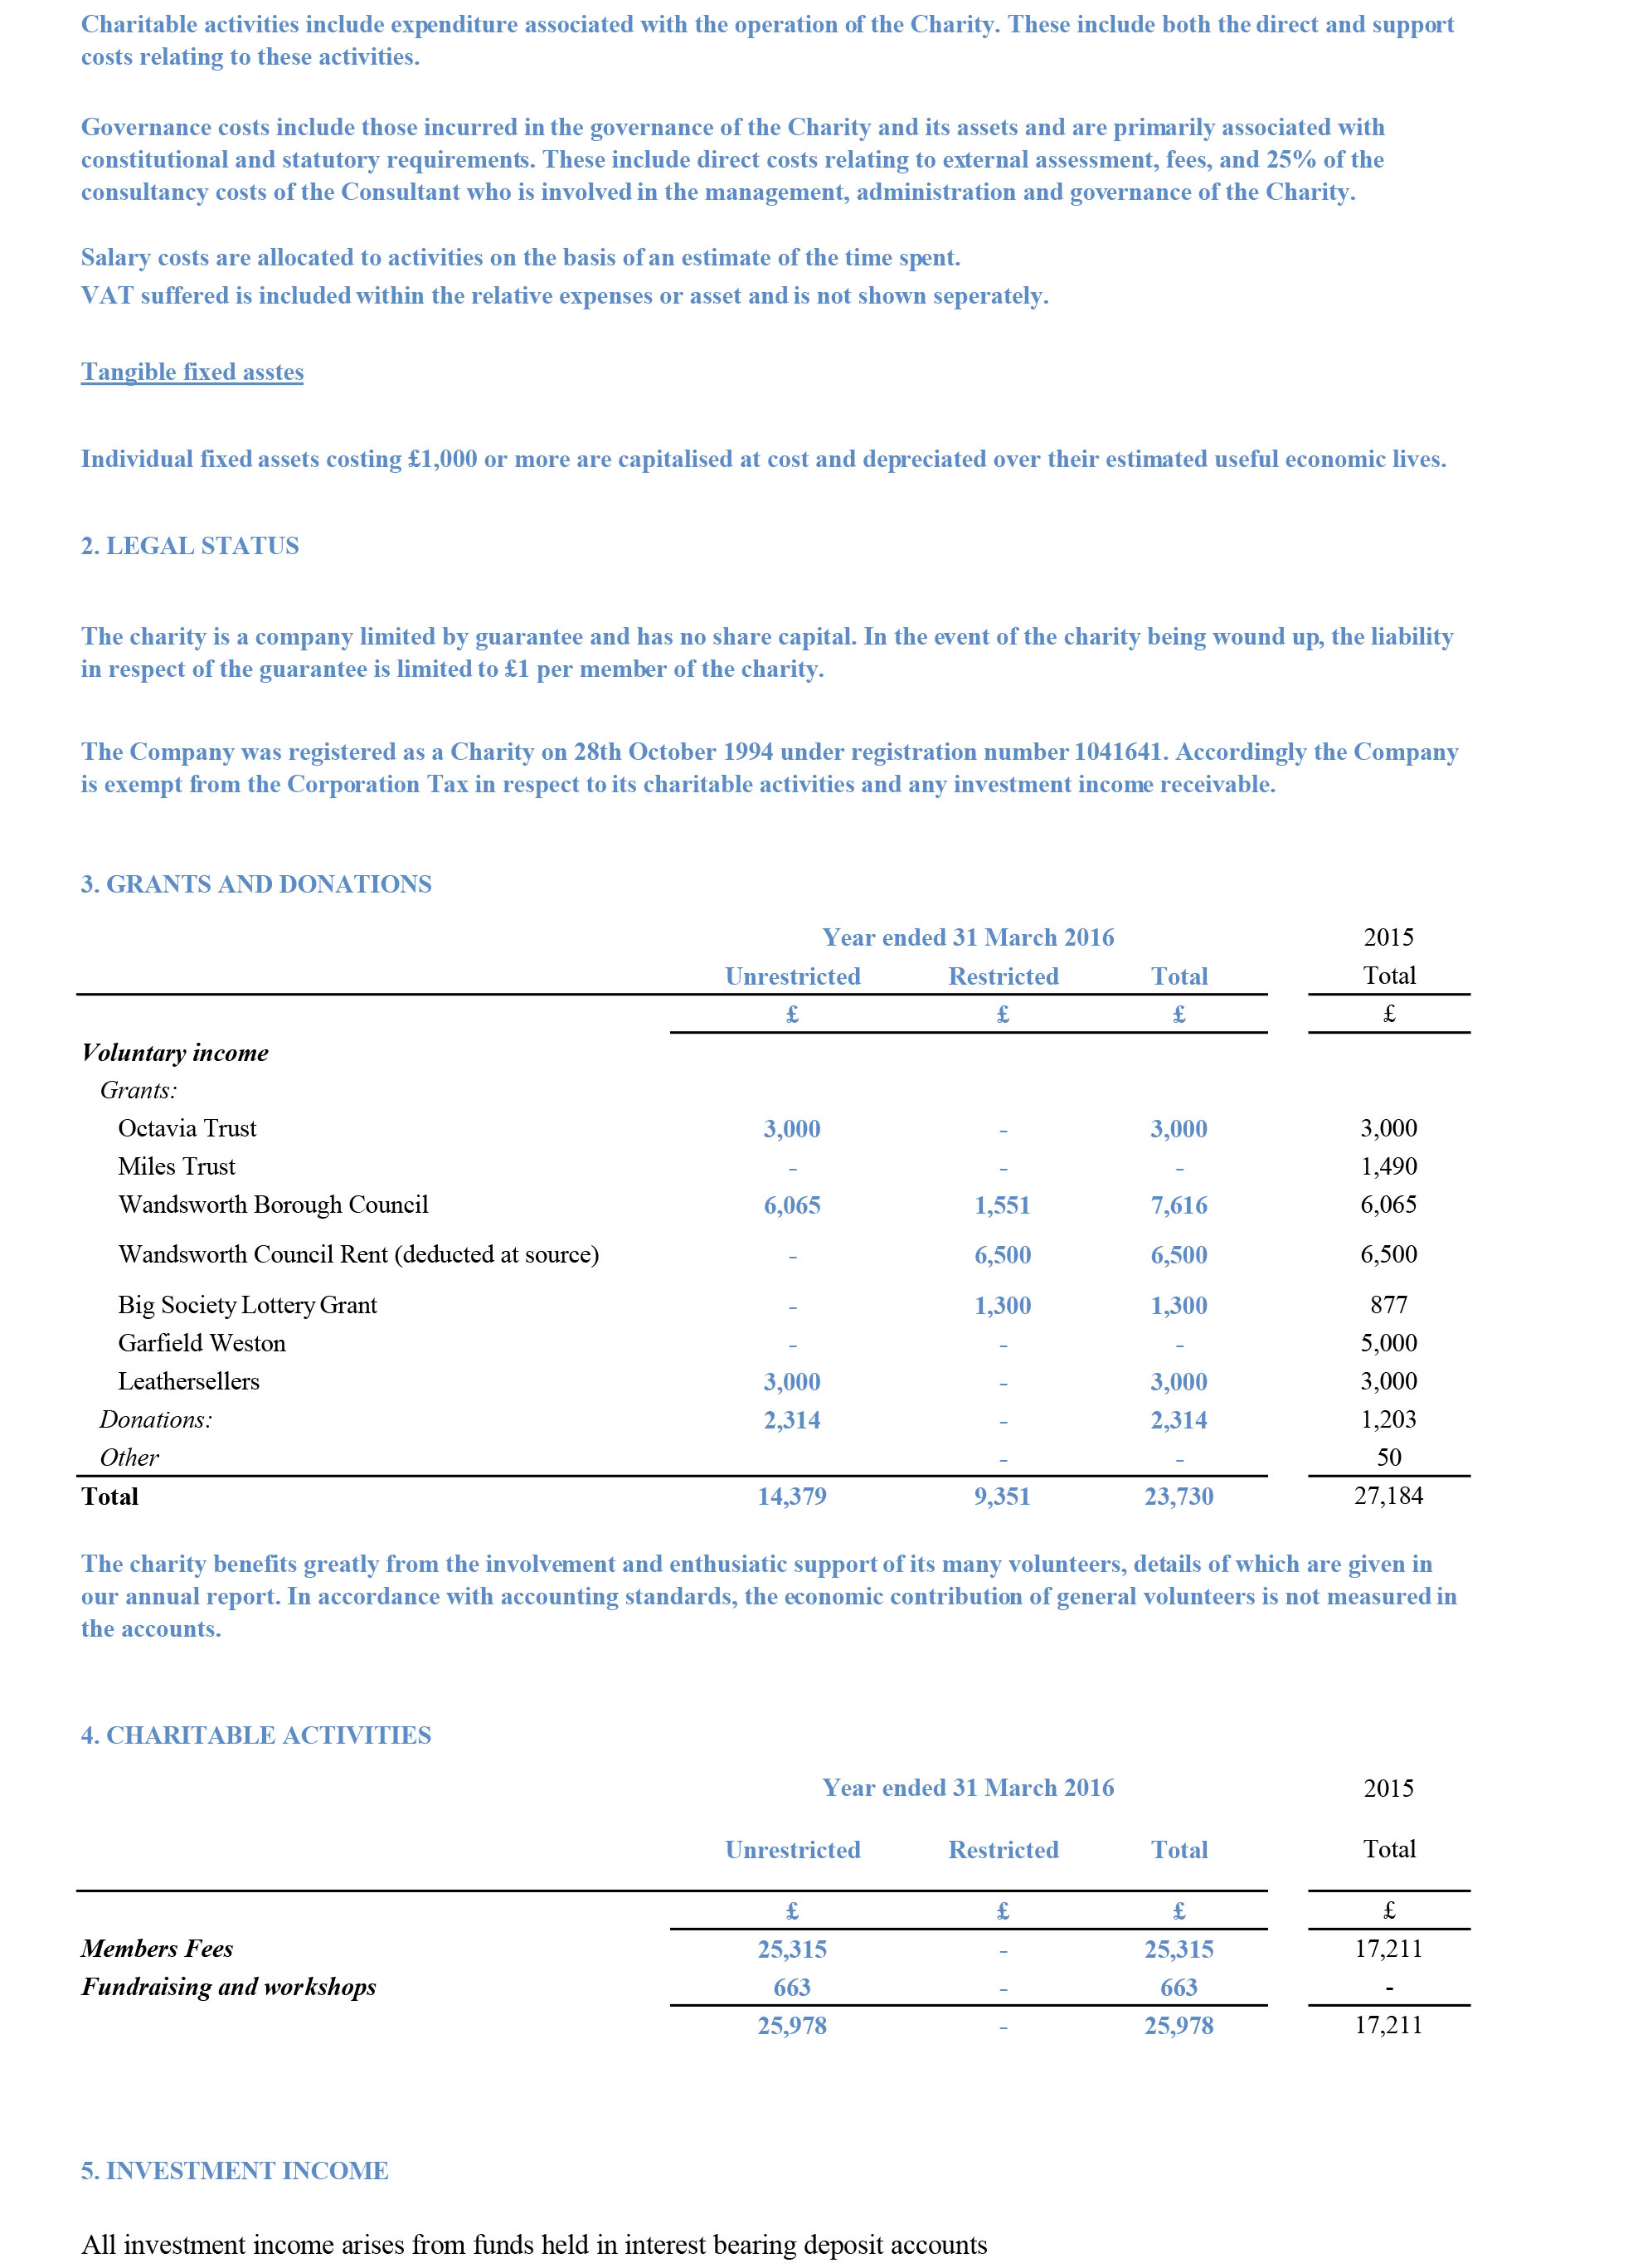

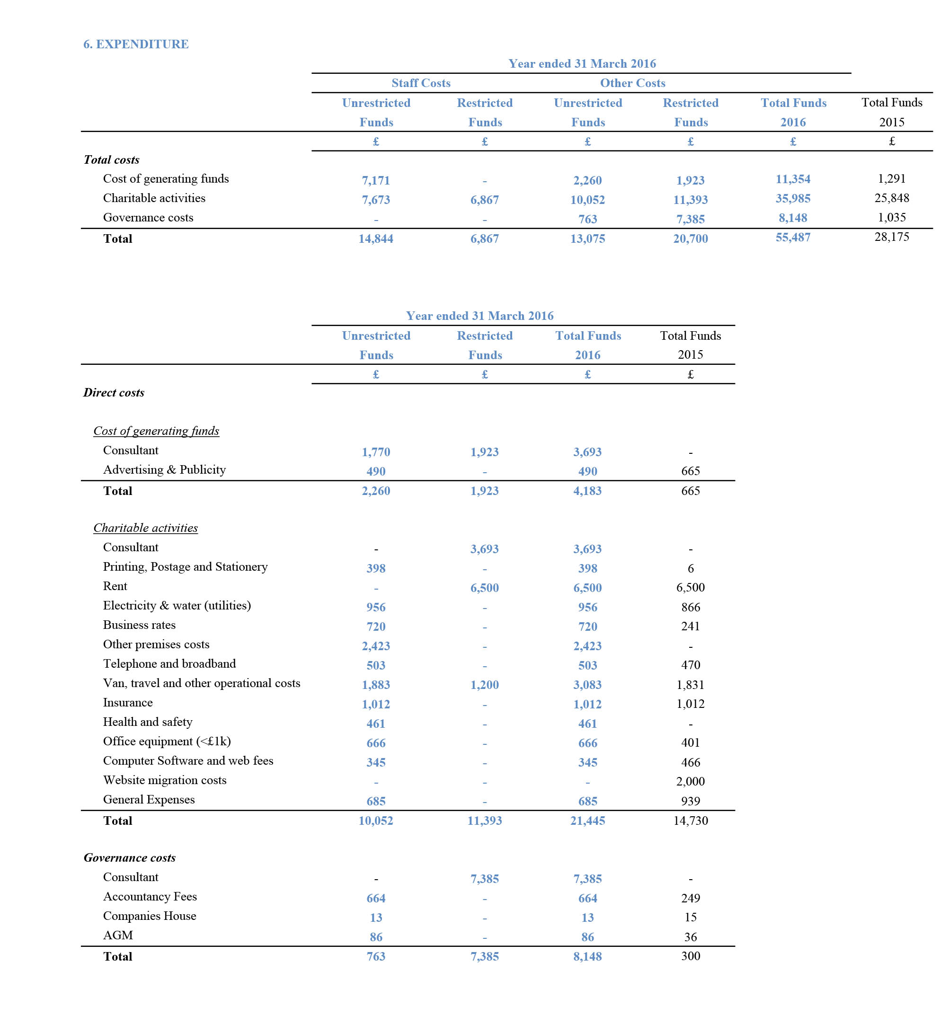
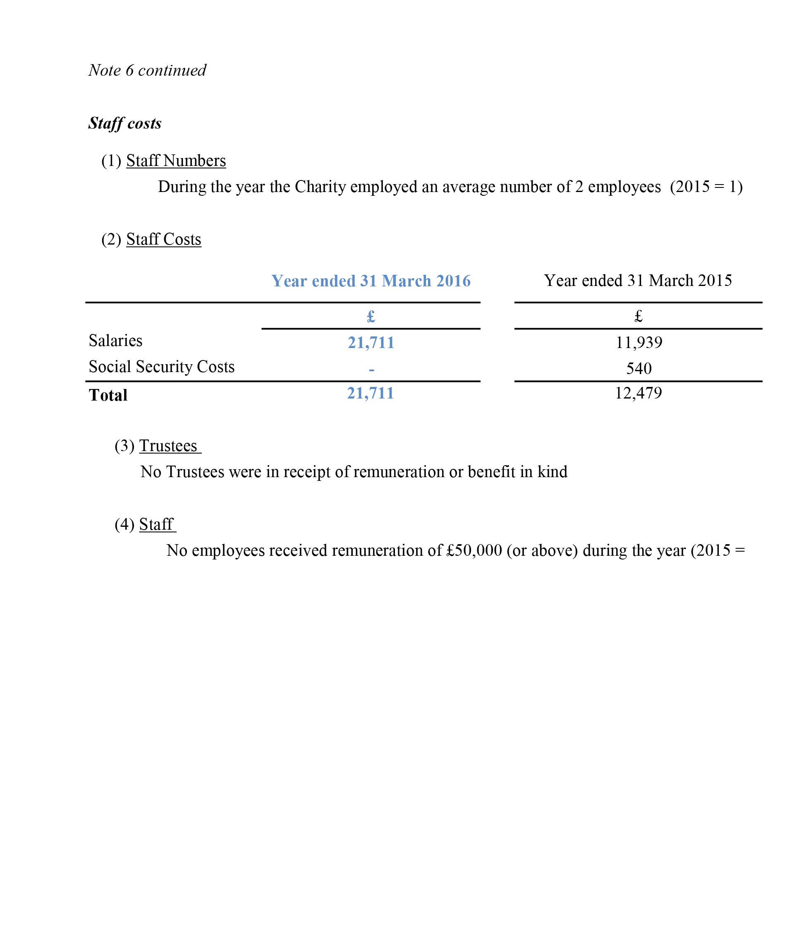

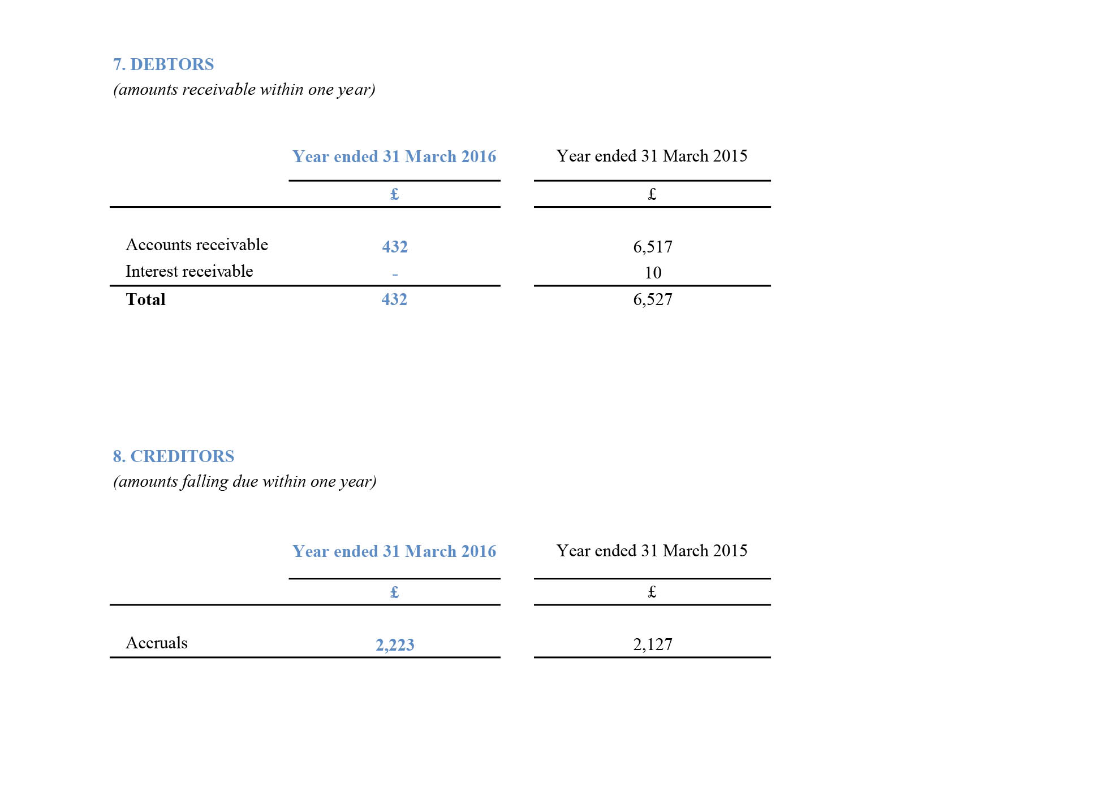

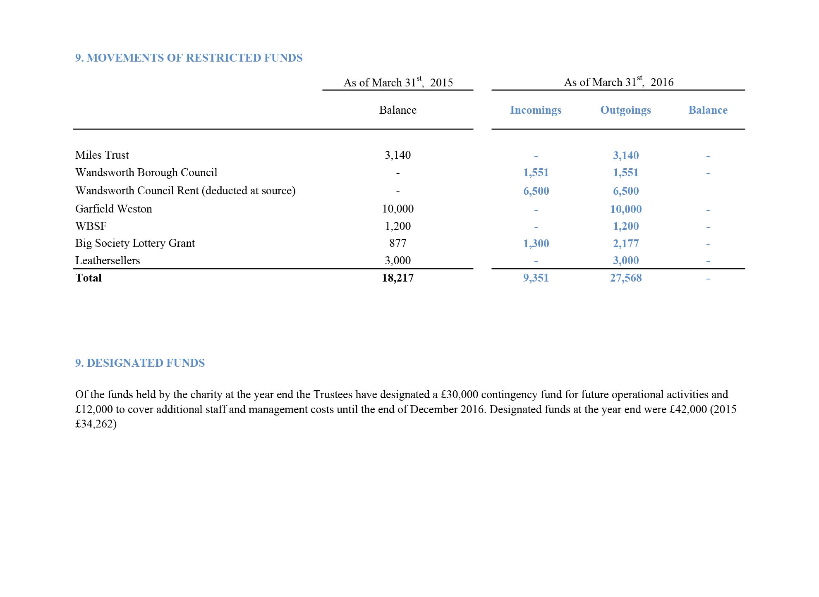

Independent examiner’s report to the trustees of Wandsworth Work and Play

I report on the accounts of Wandsworth Work and Play for the year ending 31st March 2016.
Respective responsibilities of trustees and examiner
The charity’s trustees are responsible for the preparation of the accounts. The charity’s trustees consider that an audit is not required for this year under section 144 (2) of the Charities Act 2011 or Part 16 of the Companies Act 2006, and that an independent examination is needed.
It is my responsibility:
To examine the accounts under section 145 of the Charities Act 2011;
To follow the procedures laid down in the general Directions given by the Charity Commission under Section 145 (5)(b) of the Charities Act 2011; and
To state whether particular matters have come to my attention.
Basis of Independent Examiner’s Report
My examination was carried out in accordance with the general Directions given by the Charity Commission. An examination includes a review of the accounting records kept by the charity and a comparison of the accounts with those records. It also includes consideration of any unusual items or disclosures in the accounts and seeking explanation from you trustees concerning such matters. The procedures undertaken do not provide all the evidence that would be required in an audit and consequently no opinion is given as to whether the accounts present a ‘true and fair view’ and the report is limited to those matters set out in the statement below.

Independent examiner’s statement
Statement of Recommended Practice applicable to charities preparing their accounts in accordance with the Financial Reporting Standards for Smaller Entities (the FRSSE) (effective 1 January 2015) requires that donated goods held by the charity for distribution to its beneficiaries should be recognised as stock with the corresponding income recognised within donations and measured at its fair value. In the reporting period in which the stocks are distributed they are recognised as an expense in the appropriate category in the Statement of Financial Activities.
The accounts of Work and Play Scrapstore are not consistent with this requirement as, in the opinion of the Trustees, due to the nature of the goods donated and distributed to beneficiaries there is no sufficiently reliable method of measurement of the fair value of these items and therefore under the income recognition policies also outlined in SORP (FRSSE) these donated goods are not included in either stock, income or expenditure.
Other than this in connection with my examination, no matter has come to my attention:
Which gives me reasonable cause to believe that in any material respect the requirements:
to keep accounting records in accordance with section 130 of the Charities Act 2011 Act and section 386 of the Companies Act 2006; and
to prepare accounts which accord with the accounting records and comply with the accounting requirements of the Charities Act 2011, section 396 of the Companies Act 2006 and the methods and principles of the Statement of Recommended Practice applicable to charities preparing their accounts in accordance with the Financial Reporting Standards for Smaller Entities (the FRSSE) (effective 1 January 2015) .
have not been met; or
To which, in my opinion, attention should be drawn in order to enable a proper understanding of the accounts to be reached.

Sarah Buttars FCA
Brensham Cottage
Malting Lane
Aldbury
HP23 5RH

Date:

Wandsworth Work and Play, Hazelhurst Estate, 13 Blackshaw Road, London SW17 0DA
www.workandplayscrapstore.org.uk info@workandplayscrapstore.org
Tel: 0208 682 4216

Supported by Wandsworth Borough Council, the Leathersellers’ Company, Miles Trust,
Garfield Weston, and others.

Charity No 1041641 Company No 2234306

